**Murtador Olajobi**

**Front-End Web Developer**

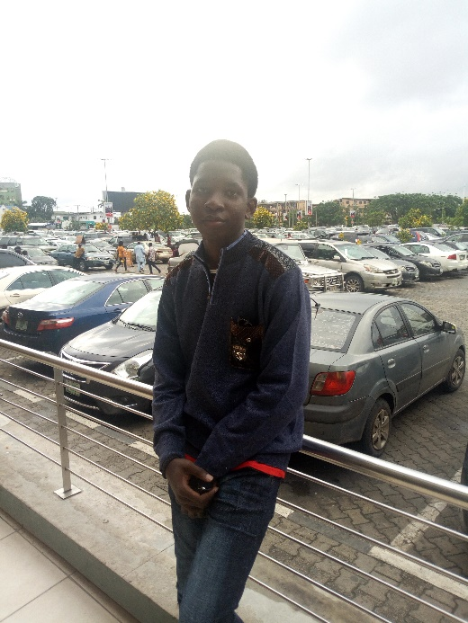

Phone:08183662841, 07083250828.

Email: mtdolaj@gmail.com

*LinkedIn:*

[linkedin.com/in/murtador-olajobi-36b473165](https://www.linkedin.com/in/murtador-olajobi-36b473165)

*Twitter:*

https://twitter.com/mtdola

*GitHub:*

https://github.com/mtdola  
Facebook:

<https://www.facebook.com/Mtd.Ola.187>

Instagram:

@murtadore

**EDUCATION**

|  |  |
| --- | --- |
| SCHOOL | University of Lagos |
| Faculty | Engineering |
| Department | Electrical and Electronics |
| Level | 100 |
| Best Course so far | Optics |